**How any Adapter is working:**

* Inside Adapter Class definitely, we have one **adapter declaration object**.
* Copy that object and search in **bean** xml
* And we have one bean declaration with command class
* Inside **command** class have three interfaces:
  + **RequestCreator** 🡪Which will take the any context and convert to third part request
  + **Operation** 🡪 It will call to third party url with generated third-party request and it will response third party response
  + **ResponseProcessor** 🡪 third party response convert to our response
* Example:
* 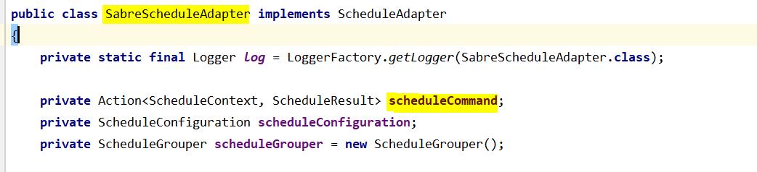
* Copy scheduleCommand
* Search in bean.xml
* 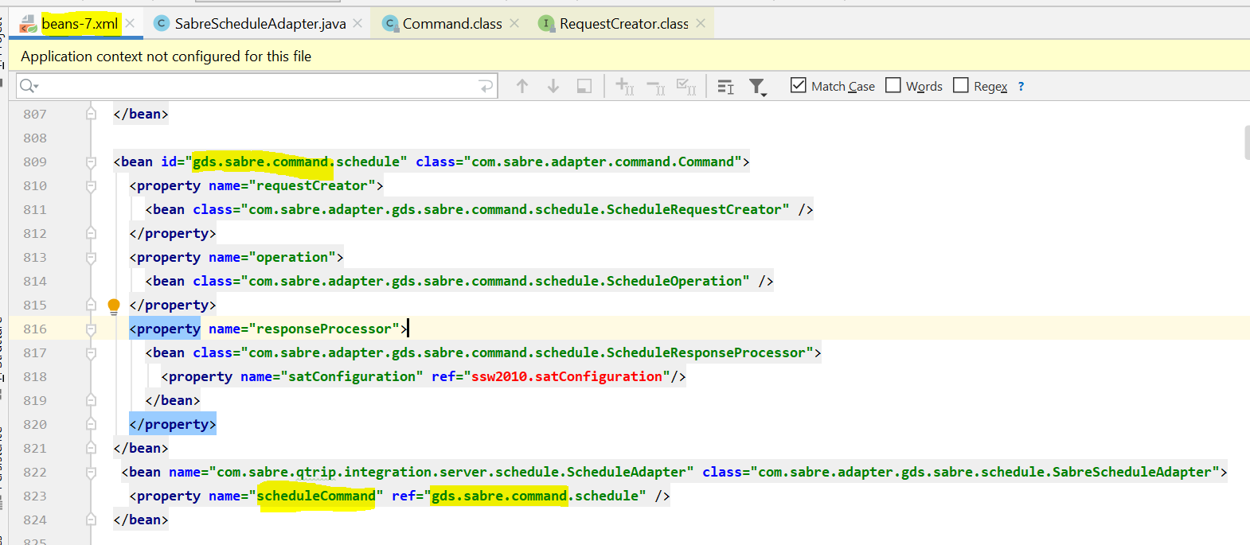
* **Action.class**
* 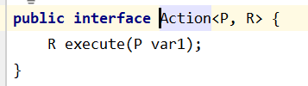
* So ScheduleContext is P and ScheduleResult is R and called to execute method in Command Class
* **Command.java**
* 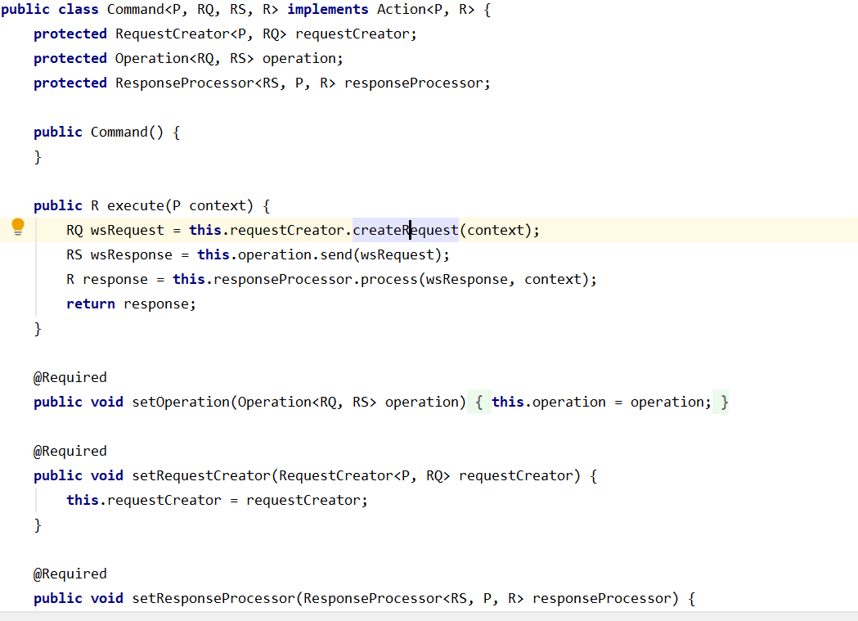
* 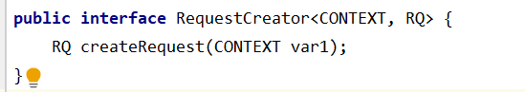
* 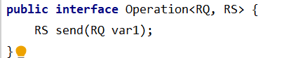
* 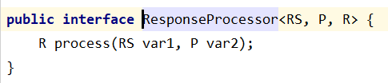
* Now open bean.xml and click the com.sabre.adapter.gds.sabre.command.schedule.ScheduleRequestCreator
* And you will see one method request will create and get the method internal RQ value
* Now click <bean class="com.sabre.adapter.gds.sabre.command.schedule.ScheduleOperation" />
* And you will get RS value
* And now you will click <bean class="com.sabre.adapter.gds.sabre.command.schedule.ScheduleResponseProcessor">
* You will pass RS and P and you will get R which is the actual result.

Now you will get the result.